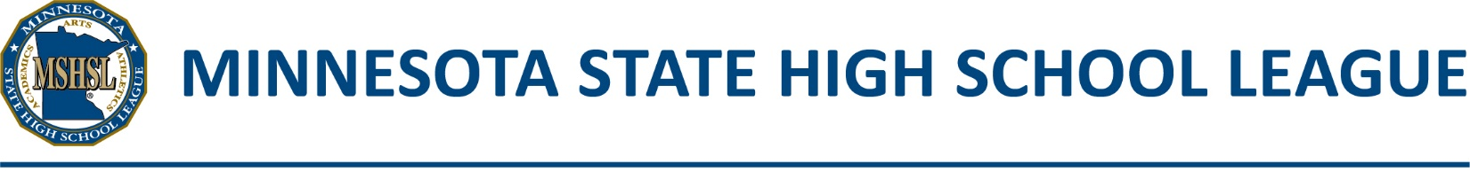

MUSIC TROPHY PERMIT AND ORDER FORM
(DEADLINE FOR AWARD ORDER: MAY 10th, 2024)

Trophy includes Minnesota State High School League seal and a gold inscription plate WITHOUT engraving.

Mail orders with payment directly to: Trophies Plus
115 Main Street, PO Box 206
Breda, IA 51436

Please enclose a check made payable to Trophies Plus, Inc. with your order. No Purchase Orders will be accepted.

Trophies Plus will engrave the plate for you, for an additional fee of $8.00. Maximum 7 lines, 125 characters.

Section or Subsection managers please indicate number of trophies to which each school is entitled and sign. Price for trophies are $35.00 w/o engraving and $42.00 with engraving.

Event | Authorized by Section Manager | Ordered by School | Amount
Choir
Glee Club
Orchestra
Band
Jazz Ensemble
Pop Choir
Chamber Singers
 | TOTALS

This certifies that the school listed below is entitled to purchase the above trophies.
Section/Subsection Manager Signature

Please, fill in the above order as authorized, indicating the quantity of awards needed. Combine all full year music trophy orders into one single order for your school. The order for large group trophies must not exceed the manager’s authorization.
INFORMATION BELOW MUST BE COMPLETED FOR THE ORER TO BE PROCESSED
Purchaser’s Name: |  |  |  |  |  |  | Title:
Name of School:
Address: |  |  |  |  | City/State/Zip:
Phone Number: |  |  |  |  | Presentation Date:

